TASK 4 – RESPONSIBLE AI & MODEL INTERPRETATION
1. Objective
The objective of this project is to analyze the fairness, interpretability, and explainability of a machine learning classification model. The project uses model interpretation techniques such as feature importance, SHAP values, and SHAP interaction analysis to understand how different features influence model predictions.
The project also evaluates the classification model using accuracy, precision, recall, and F1-score and considers responsible AI aspects such as transparency, bias, and model limitations.
2. Project Description
This project focuses on understanding and interpreting the predictions of a machine learning classification model using the Breast Cancer Wisconsin dataset.
The dataset contains 569 samples and 30 features and has two target classes:
- Malignant
- Benign
A trained machine learning model is analyzed to understand which features contribute most to its predictions. Feature importance is calculated and visualized using a Top 10 Feature Importances graph.
To provide more detailed explanations, SHAP (SHapley Additive exPlanations) is used. SHAP values help explain how individual features influence model predictions. SHAP interaction analysis is also performed to understand relationships between features.
The model achieved an accuracy of approximately 95.61%. The classification report shows the model's precision, recall, and F1-score for malignant and benign classes.
The project was implemented using Python, Pandas, NumPy, Scikit-learn, Matplotlib, and SHAP.

3. Project Screenshots
1 – Dataset
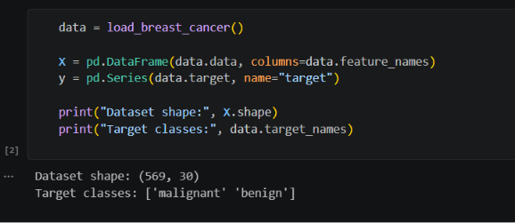
Dataset shape: (569, 30)
Target classes: ['malignant' 'benign']
Description:
The screenshot shows that the Breast Cancer dataset contains 569 samples and 30 features with two target classes: malignant and benign.

2 – Model Performance
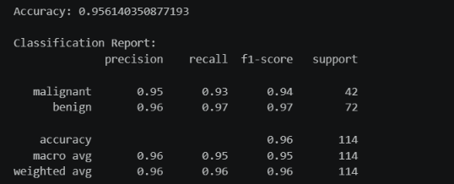
Accuracy: 0.956140350877193
The classification report shows:
Class | Precision | Recall | F1-score
Malignant | 0.95 | 0.93 | 0.94
Benign | 0.96 | 0.97 | 0.97
Description:
The model achieved approximately 95.61% accuracy. The classification report demonstrates good performance for both malignant and benign classes.

3 – Top 10 Feature Importances
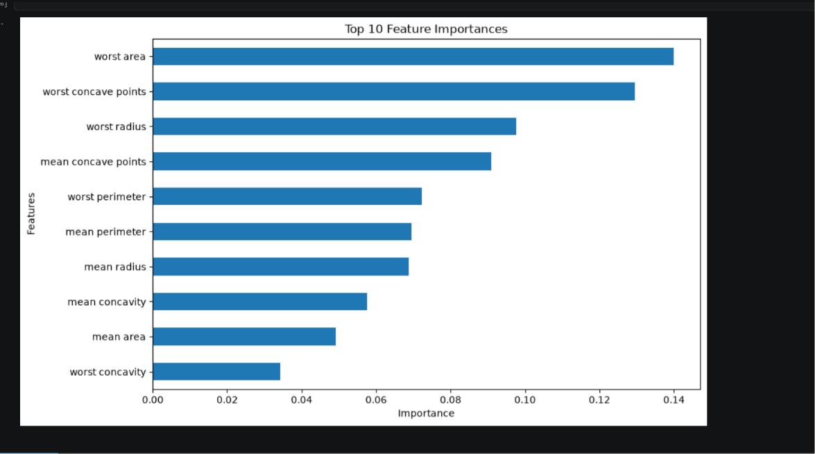
Description:
The graph displays the ten most important features used by the model. Worst area has the highest importance among the features shown, followed by worst concave points, worst radius, and mean concave points.
This analysis helps identify which features have the greatest influence on the model's predictions.

4 – SHAP Values
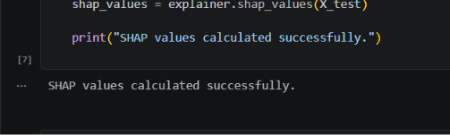
SHAP values calculated successfully.
Description:
SHAP values are calculated to explain the contribution of individual features to the model's predictions. SHAP provides a way to interpret the behaviour of the machine learning model.

5 – SHAP Interaction Plot
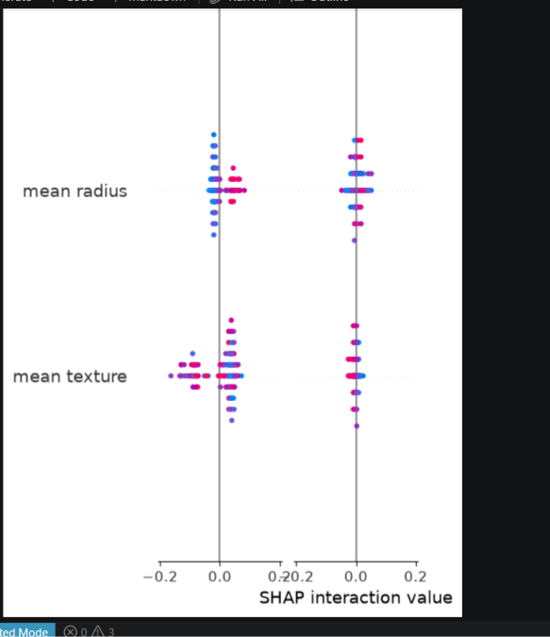
Description:
The SHAP interaction plot helps analyze how features interact with each other and how these interactions can influence model predictions. The visualization includes features such as mean radius and mean texture.

4. Code Snippets
# ============================================================
# INTERNSPARK AI INTERNSHIP
# TASK 4 - RESPONSIBLE AI & MODEL INTERPRETATION
# ============================================================

# ============================================================
# 1. IMPORT LIBRARIES
# ============================================================

import numpy as np
import pandas as pd
import matplotlib.pyplot as plt
import shap

from sklearn.datasets import load_breast_cancer
from sklearn.model_selection import train_test_split
from sklearn.ensemble import RandomForestClassifier
from sklearn.metrics import (
accuracy_score,
classification_report,
confusion_matrix,
ConfusionMatrixDisplay
)

print("=" * 65)
print("TASK 4 - RESPONSIBLE AI & MODEL INTERPRETATION")
print("=" * 65)

# ============================================================
# 2. LOAD DATASET
# ============================================================

data = load_breast_cancer()

X = pd.DataFrame(
data.data,
columns=data.feature_names
)

y = pd.Series(
data.target,
name="target"
)

print("\n" + "=" * 65)
print("DATASET INFORMATION")
print("=" * 65)

print("Dataset shape:", X.shape)
print("Number of features:", X.shape[1])
print("Number of samples:", X.shape[0])
print("Target classes:", data.target_names)

print("\nFirst 5 rows:")
print(X.head())

# ============================================================
# 3. CHECK MISSING VALUES
# ============================================================

print("\n" + "=" * 65)
print("MISSING VALUE CHECK")
print("=" * 65)

missing_values = X.isnull().sum().sum()

print("Total missing values:", missing_values)

if missing_values == 0:
print("No missing values found.")
else:
print("Missing values are present.")

# ============================================================
# 4. DISPLAY CLASS DISTRIBUTION
# ============================================================

print("\n" + "=" * 65)
print("CLASS DISTRIBUTION")
print("=" * 65)

class_counts = y.value_counts().sort_index()

for class_number, count in class_counts.items():
print(
data.target_names[class_number],
":",
count
)

plt.figure(figsize=(7, 5))

plt.bar(
data.target_names,
class_counts.values
)

plt.title("Class Distribution")
plt.xlabel("Class")
plt.ylabel("Number of Samples")

plt.tight_layout()
plt.show()

# ============================================================
# 5. TRAIN-TEST SPLIT
# ============================================================

print("\n" + "=" * 65)
print("TRAIN-TEST SPLIT")
print("=" * 65)

X_train, X_test, y_train, y_test = train_test_split(
X,
y,
test_size=0.20,
random_state=42,
stratify=y
)

print("Training samples:", X_train.shape[0])
print("Testing samples:", X_test.shape[0])

# ============================================================
# 6. CREATE RANDOM FOREST MODEL
# ============================================================

print("\n" + "=" * 65)
print("BUILDING RANDOM FOREST MODEL")
print("=" * 65)

rf_model = RandomForestClassifier(
n_estimators=100,
random_state=42
)

rf_model.fit(
X_train,
y_train
)

print("Random Forest model trained successfully.")

# ============================================================
# 7. MAKE PREDICTIONS
# ============================================================

rf_pred = rf_model.predict(X_test)

print("\nPredictions generated successfully.")

# ============================================================
# 8. MODEL ACCURACY
# ============================================================

accuracy = accuracy_score(
y_test,
rf_pred
)

print("\n" + "=" * 65)
print("MODEL PERFORMANCE")
print("=" * 65)

print(
"Random Forest Accuracy:",
accuracy
)

print(
"Accuracy Percentage:",
round(accuracy * 100, 2),
"%"
)

# ============================================================
# 9. CLASSIFICATION REPORT
# ============================================================

print("\n" + "=" * 65)
print("CLASSIFICATION REPORT")
print("=" * 65)

print(
classification_report(
y_test,
rf_pred,
target_names=data.target_names
)
)

# ============================================================
# 10. CONFUSION MATRIX
# ============================================================

print("\n" + "=" * 65)
print("CONFUSION MATRIX")
print("=" * 65)

cm = confusion_matrix(
y_test,
rf_pred
)

print(cm)

disp = ConfusionMatrixDisplay(
confusion_matrix=cm,
display_labels=data.target_names
)

disp.plot()

plt.title("Random Forest Confusion Matrix")
plt.tight_layout()
plt.show()

# ============================================================
# 11. FEATURE IMPORTANCE
# ============================================================

print("\n" + "=" * 65)
print("FEATURE IMPORTANCE ANALYSIS")
print("=" * 65)

importance = rf_model.feature_importances_

feature_importance = pd.Series(
importance,
index=X.columns
).sort_values(
ascending=False
)

print("\nTop 10 Important Features:")

print(
feature_importance.head(10)
)

# ============================================================
# 12. PLOT TOP 10 FEATURES
# ============================================================

top_features = feature_importance.head(10)

plt.figure(figsize=(9, 6))

top_features.sort_values().plot(
kind="barh"
)

plt.title(
"Top 10 Feature Importances"
)

plt.xlabel("Importance")
plt.ylabel("Features")

plt.tight_layout()
plt.show()

# ============================================================
# 13. SHAP EXPLAINER
# ============================================================

print("\n" + "=" * 65)
print("SHAP ANALYSIS")
print("=" * 65)

explainer = shap.TreeExplainer(
rf_model
)

shap_values = explainer.shap_values(
X_test
)

print("SHAP values calculated successfully.")

# ============================================================
# 14. SHAP SUMMARY PLOT
# ============================================================

print("\nGenerating SHAP summary plot...")

# Handle different SHAP output formats
if isinstance(shap_values, list):

# Binary classification
shap.summary_plot(
shap_values[1],
X_test,
show=True
)

else:

shap.summary_plot(
shap_values,
X_test,
show=True
)

# ============================================================
# 15. SHAP BAR PLOT
# ============================================================

print("\nGenerating SHAP feature importance plot...")

if isinstance(shap_values, list):

shap.summary_plot(
shap_values[1],
X_test,
plot_type="bar",
show=True
)

else:

shap.summary_plot(
shap_values,
X_test,
plot_type="bar",
show=True
)

# ============================================================
# 16. SHAP INTERACTION ANALYSIS
# ============================================================

print("\n" + "=" * 65)
print("SHAP INTERACTION ANALYSIS")
print("=" * 65)

try:

shap_interaction_values = (
explainer.shap_interaction_values(
X_test
)
)

print(
"SHAP interaction values calculated successfully."
)

# For binary classification
if isinstance(
shap_interaction_values,
list
):

interaction_values = (
shap_interaction_values[1]
)

else:

interaction_values = (
shap_interaction_values
)

# Display interaction summary
shap.summary_plot(
interaction_values,
X_test,
show=True
)

except Exception as e:

print(
"SHAP interaction analysis could not be displayed."
)

print("Reason:", e)

# ============================================================
# 17. INDIVIDUAL PREDICTION EXPLANATION
# ============================================================

print("\n" + "=" * 65)
print("INDIVIDUAL PREDICTION")
print("=" * 65)

sample_index = 0

sample = X_test.iloc[
[sample_index]
]

actual_class = y_test.iloc[
sample_index
]

predicted_class = rf_model.predict(
sample
)[0]

print(
"Actual Class:",
data.target_names[actual_class]
)

print(
"Predicted Class:",
data.target_names[predicted_class]
)

# ============================================================
# 18. PREDICTION PROBABILITY
# ============================================================

probabilities = rf_model.predict_proba(
sample
)[0]

print("\nPrediction Probabilities:")

for i, probability in enumerate(
probabilities
):

print(
data.target_names[i],
":",
round(probability * 100, 2),
"%"
)

# ============================================================
# 19. RESPONSIBLE AI SUMMARY
# ============================================================

print("\n" + "=" * 65)
print("RESPONSIBLE AI ANALYSIS")
print("=" * 65)

print("""
Responsible AI considerations:

1. Model Interpretability
Feature importance and SHAP are used to understand
which features influence model predictions.

2. Transparency
SHAP explanations provide additional information
about individual model predictions.

3. Bias Awareness
Model performance should be evaluated carefully
before applying the system to real-world users.

4. Human Oversight
Machine learning predictions should support
decision-making rather than automatically replace
appropriate human judgment.

5. Model Limitations
The model is trained using a specific dataset and
may not generalize perfectly to every population.
""")

# ============================================================
# 20. FINAL SUMMARY
# ============================================================

print("\n" + "=" * 65)
print("PROJECT SUMMARY")
print("=" * 65)

print("Dataset: Breast Cancer Wisconsin")
print("Samples:", X.shape[0])
print("Features:", X.shape[1])
print("Model: Random Forest Classifier")
print(
"Accuracy:",
round(accuracy * 100, 2),
"%"
)

print("Feature importance analysis: Completed")
print("SHAP analysis: Completed")
print("Responsible AI analysis: Completed")

print("\nTASK 4 COMPLETED SUCCESSFULLY!")
Conclusion
The Responsible AI & Model Interpretation project was successfully implemented using the Breast Cancer dataset and a Random Forest classification model. The model achieved approximately 95.61% accuracy. Feature importance analysis identified the most influential features, while SHAP analysis provided insights into how individual features contributed to model predictions. SHAP interaction analysis further helped understand relationships between features. Overall, the project demonstrates the importance of model transparency, interpretability, and responsible use of AI.

